REFACTORING LIST
Team 11

By compare between the implementation of the build 2 and the requirement of build 3, We listed following refactoring list:

- Display the dice info when a player is attacking
Build 2 | Dice info is in the black box, player cannot see.
Build 3 | required to display the dice info.
Decision | Required
Solution | Out put the dice info in the console.

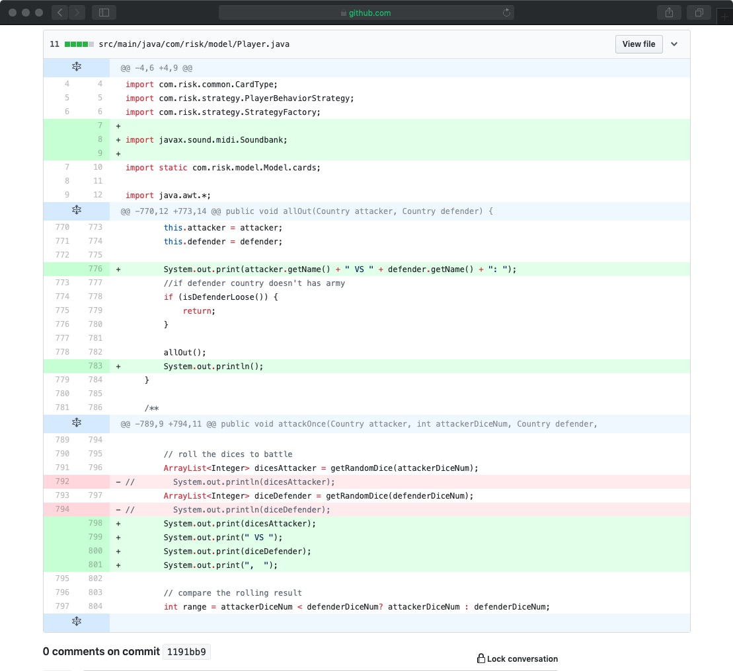

- Create the strategy pattern, move the methods reinforcement(), attack(), moveArmy(), and fortification(), four method to the ManualStrategy class.
Build 2 | Methods reinforcement(), attack(), moveArmy(), and fortification() are in player class.
Build 3 | Implementation of different player behaviors using the Strategy pattern
Decision | Required
Solution | - Create the strategy interface: PlayerBehaviorStrategy;  - Create HumanStrategy class implements PlayerBehaviorStrategy, and move reinforcement(), attack(), moveArmy(), and fortification() methods to HumanStrategy class.

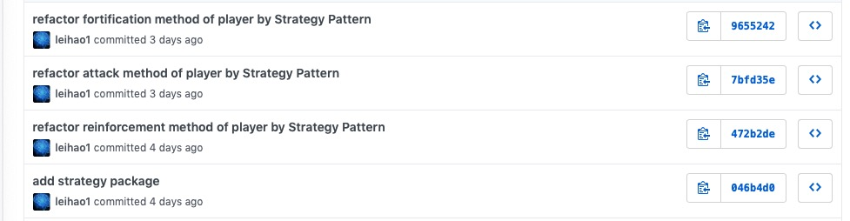

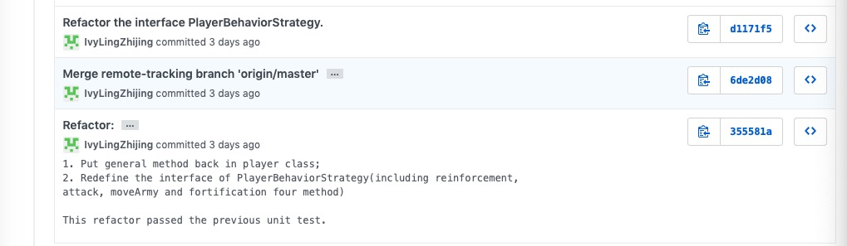

- Singleton instance as a class variable
Build 2 | Some class create a class variable when it’s a singleton instence
Build 3 | --
Decision | Required, it will occur some error when reload the game
Solution | Use getInstence() to get the unique instance of singleton

